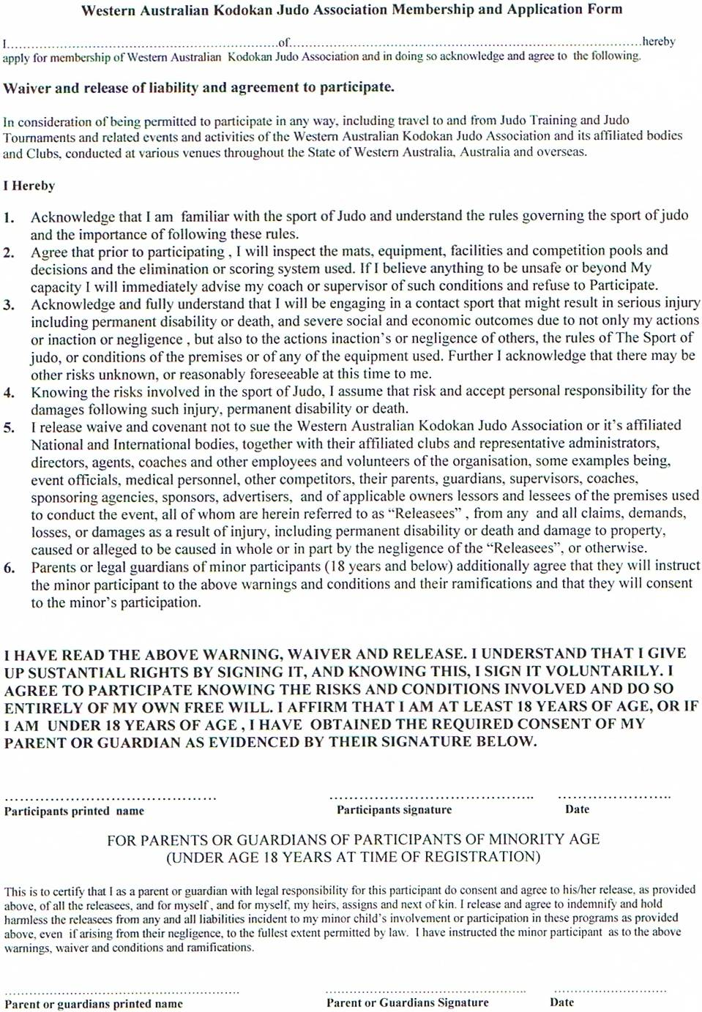

WESTERN AUSTRALIAN

KODOKAN JUDO ASSOCIATION INC.
Member State of the Australian Kodokan Judo Association
Registration and Transfer Form 2015
Please tick type of registration: NEW RENEWAL TRANSFER

COSTS: Junior – 1 child $25.00, 2 children $40.00, 3 or more children $50.00. Senior $40.00.
Total: $______________
Please complete all sections below
Mr/Mrs/Ms: ______ Surname: _______________________ First names: _________________________________
Address: _________________________________________________________________Post Code___________
Phone: ( )_______________________Date of birth: ____________________ Sex: ________ Age: _________
Email: _______________________________________or____________________________________________
Current judo grade (if any): _____________________________________________________________________
Referee grade if applicable: National: ___________________________ State: ____________________________

Registration is based on a 12 month period from January 1st to December 31st in the same year. Those registering after the start of the 12 month period above should consult with their club supervisor as to the percentage of fee payable.
Bank Details (Please put the transfer description as your surname).
BSB: 306-059 Account Number: 4195953
Account Name: Western Australian Kodokan Judo Association.
THIS FORM NEEDS TO BE SENT TO THE WAKJA SECRETARY VIA YOUR CLUB SUPERVISOR
DECLARATION (to be signed by parent/guardian if member is under the age of 18):
I understand that WAKJA is an incorporated body and that as a member, I/the child named am bound by the rules that govern the association under incorporation.

Signed: _________________________________. Relationship to the above named if under 18: _____________.
ARE THERE ANY MEDICAL CONDITIONS THAT THE KODOKAN JUDO ASSOCIATION SHOULD BE MADE AWARE OF?
_________________________________________________________________________________________.
Club: ___________________________________________ Instructor: ___________________________________
Registration number: _________________ Last graded: ____/____/_____ First joined WAKJA: ____/____/____
Parent/Guardian: _________________________________________________ Phone: ( ) ________________

